INTRODUCTION

1

1. INTRODUCTION

A CUSTOMER SERVICE STATUSreport system for Mihira Technology was developed to record the opinion of customer towards the software/website procured by them.

Customer service status report is an online application, which is used to create a digital copy of all the data that is produced, thereby reducing the time taken for processing and analysing all the reports that are generated. An User can register online for being a member. In the customer service status report, each registered user can upload the digital copy of their feedback or compliant under the respective categories.

The project proved to be a large undertaking as a significant amount of time was spent delving into the details of designing of every page . The amount of work required significant breakdown by services. I hope the following can accurately portray a sample of what such a software suite would require and how it could be coded to become a reality.

Hence working on this project helped me in understanding the concept of relational database management system and knowing different types of technologies that can be implemented for the front-end and designing the web pages.

Mihira   
Technology

2

1. Mihira Technology

Mihira Technology is specialized in Software and Web Development. The basic concept of Mihira Technology is to cater to the needs of various business communities who are interested in customized software and web solution. Mihira Technology believes in giving product to their customers at a very competitive cost and hence various strategies are implemented from time to time for providing products at a reduced cost. It also has general software which is "ready to use" by some business communities and also by individuals.

 They are specialized in making customized software and web solution and readymade software which includes providing space, domain registration, web design & development to commercial, government and non-profit organizations. Mihira Technology has been recognized by the industries for its exceptional performance, expert advice and quality services. The team has acquired extensive experience in Software and Web Development. Its in-house team includes analysts, developers, designers, testers and trouble shooters. The organization is equipped with various platforms, creating attractive and user-friendly Websites and software. Their goal is to serve as a source of quality Software and Website development.

We are now providing E - Commerce platform for easing business and also providing various innovative products to school.

Their vision is: "We are committed to make our customer’s globally approachable and to accelerate the pace of business by way of web solution and providing software solution."

Mihira Technology always expects serving individual, NGOs, Charitable Institution, Small and Medium Size organization too. They are creating awareness about the situation of the earth which is a serious concern to the entire world i.e. global warming primarily among students and other communities. To eliminate the seriousness of the issue, Mihira Technology is also contributing in a small way by introducing products like E-Dairy, E-Album, Password Directory, Nano Wallet

* E-Diary - Maintain address, can write diary, remember birthdays and other occasions along with phone no’s, email-ids and much more.
* E-Album - Can keep photos, videos in organized manner.
* Password Directory – A way to preserve password effectively and securely
* Nano wallet - Helps to manage Investment.

Some of the major products are Edisoft (Educational Institute software), Library Management System, Book Store-Management System, Payroll Management System, Laboratory Management System, Invoice/Billing System, Medwon, www.gurukoolonline.com (easing school, teachers, students and parents pressure) and [www.contactglobally.com](http://www.contactglobally.com) for the growth of business communities.

Edisoft - A system for all tings in a school

Library Management System – Used to keep record of books issued, bought, etc.

Book Store-Management System – For keeping a record of new books and purchases.

Payroll Management System – Payment of employees of a organisation.

Laboratory Management System – A system designed for accounting of all the equipment inside the laboratory.

Invoice/Billing System –For error free calculations and records.

Medwon – A software to store details of a medicine along with its quantities.

* 1. Partnership with Mihira Technology

Mihira Technology also collaborates with individuals or organisations, and they are categorised into two groups.

* Business Associate (BA)
* Business Builder (BB)

**BUSINESS ASSOCIATES(BA)** are eligible individual/firm who will be given marketing and supporting right to sell/market the product of Mihira Technology. They will be responsible for marketing the different layers of product as per the norms of Mihira Technology.

**BUSINESS BUILDERS(BB)** are individuals responsible for selling the selected products through themselves or through Business Builders recruited by them.

As all BA`s and BB`s are working in collaboration with Mihira technology for marketing and supporting the products sold by them, the Service report for all the services that are provided need to be kept in a well organised manner and be readily accessible. Hence, this system “Customer Service Status Report” was created. That helps to keep record of all individuals and groups working in collaboration with Mihira Technology to help their individual businesses. This system works by giving an organisation an account at which the individual can upload all the queries that was addressed and the status of the request. And all the necessary steps that were taken in order for its solution.. The records that are uploaded will also help in getting to know better about all the person that work and how efficiently they work and how better can they solve the problems that are faced by the end-customers.

Software Requirements

3

1. Software Requirements

Front End : Visual Studio 2008 Express edition

Microsoft SDK 3.5

OR

Visual Studio 2005 Express edition

Microsoft SDK 2.0

Back End : MS SQL Server Management Studio 2005

Objective

4

1. Objective

The main objective of the Project “Customer Service Status Report” is to manage the details of customer queries, time taken, status, amount charged if any.

The purpose of the project is to build an application program to reduce the manual work that goes into handling all the Customer requests.

It keeps a track of the customer feedback and the status of request.

* 1. Requirement Analysis
* System needs store information about the people working in the organization.
* System needs to maintain quality record.
* System need to update and delete the record.
* System needs to be able the data based on search filters.
* It also needs a security system to prevent data loss.
  1. Purpose of Customer Service Status Report

In order to ensure customer loyalty, it is necessary to provide what they want. The key to successful and profitable service business is comprehending customer needs and meeting them satisfactorily. Field management requires insight into day-to-day service activities, operations, and delivery. Customer reports are critical for setting and meeting customer expectations. The purpose of a customer service report is to get direct feedback, and then take that user generated data to make better decisions in the future.

* Provide details about field service operations — work orders, customers, and technicians.
* Allow managers and executives to have real time information.
* Allows you to determine the key performance indicators (KPIs) that ensure the profitability and competitiveness of your service/business.

Languages and Tools

5

1. Languages and Tools
   1. Back end

A **Database** is a collection of related data organised in a way that data can be easily accessed, managed and updated. Any piece of information can be a data, for example name of a school. Database is actually a place where related piece of information is stored and various operations can be performed on it.

#### DBMS

DBMS is a software that allows creation, definition and manipulation of database. It is actually a tool used to perform any kind of operation on data in database. Dbms also provides protection and security to database. It maintains data consistency in case of multiple users. Here are some examples of popular database management systems are: MS Sql, MySQL, Oracle, Sybase, PostgreSQL, MongoDB etc.

#### Components of Database System

The database system can be divided into four components.

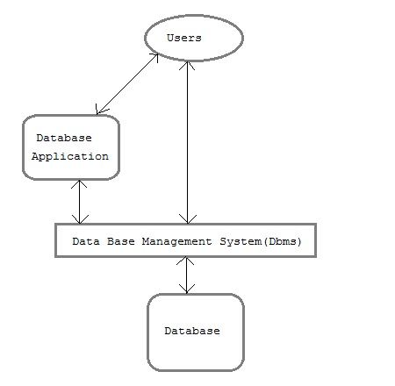

Figure 5.1 Components of Database

* **Users:** Users may be of various type such as DB administrator, System developer and End users.
* **Database application:** Database application may be Personal, Departmental, Enterprise and Internal
* **DBMS:** Software that allow users to define, create and manages database access, Ex: MySQL, Oracle etc.
* **Database:** Collection of logical data.

#### Functions of DBMS

* Provides data Independence
* Concurrency Control
* Provides Recovery services
* Provides Utility services
* Provides a clear and logical view of the process that manipulates data.

#### Advantages of DBMS

* Segregation of application program.
* Minimal data delicacy.
* Easy retrieval of data.
* Reduced development time and maintenance need.

#### Disadvantages of DBMS

* Complexity
* Costly
* Large in size
  + 1. STRUCTURED QUERY LANGUAGE

SQL ( Structured Query Language) is a [domain-specific language](https://en.wikipedia.org/wiki/Domain-specific_language) used in programming and designed for managing data held in a [relational database management system](https://en.wikipedia.org/wiki/Relational_database_management_system) (RDBMS), or for stream processing in a [relational data stream management system](https://en.wikipedia.org/wiki/Relational_data_stream_management_system) (RDSMS). It is particularly useful in handling [structured data](https://en.wikipedia.org/wiki/Data_model) where there are relations between different entities/variables of the data. SQL offers two main advantages over older read/write [APIs](https://en.wikipedia.org/wiki/API) like [ISAM](https://en.wikipedia.org/wiki/ISAM) or [VSAM](https://en.wikipedia.org/wiki/VSAM): first, it introduced the concept of accessing many records with one single command; and second, it eliminates the need to specify *how* to reach a record, e.g. with or without an [index](https://en.wikipedia.org/wiki/Database_index).

**COMMANDS**

* **ALTER TABLE**

ALTER TABLE table_name  
ADD column_name datatype;

ALTER TABLE lets you add/remove columns to a table in a database.

* **COUNT()**

SELECT COUNT( column_name)

FROM table_name;

COUNT() is a function that takes the name of a column as an argument and counts the number of rows where the column is not NULL.

* **CREATE TABLE**

CREAte TABLE table_name(column_1 datatype, column_2 datatype, … );

CREATE TABLE creates a new table in the database. It allows you to specify the name of the table and the name of each column in the table.

* **DELETE**

DELETE FROM table_name WHERE some_column = some_value;

DELETE statements are used to remove rows from a table.

* **GROUP BY**

SELECT column_name, COUNT(*)  
FROM table_name GROUPBY column_name

GROUP BY is a clause in SQL that is only used with aggregate functions. It is used in collaboration with the SELECT statement to arrange identical data into groups.

* **INSERT**

INSERT INTO table_name(column_1, column_2, column_3)  
VALUES(values_1, value_2, ‘value_3’);

INSERT statements are used to add a new row to a table.

* **IS NULL / IS NOT NULL**

SELECT column_name(s)  
FROM table_name  
WHERE column_name ISNULL;

IS NULL and IS NOT NULL are operators used with the WHERE clause to test for empty values.

* 1. Front end

The *front* is an abstraction, simplifying the underlying component by providing a [user-friendly](https://en.wikipedia.org/wiki/User-friendly) interface. Front end is a part of a web application that is needed to display the web pages, the designing of it and handling the business logic for interfacing application with back end and more.

* + 1. .NET Framework

.NET Framework  is a [software framework](https://en.wikipedia.org/wiki/Software_framework) developed by [Microsoft](https://en.wikipedia.org/wiki/Microsoft) that runs primarily on [Microsoft Windows](https://en.wikipedia.org/wiki/Microsoft_Windows). It includes a large [class library](https://en.wikipedia.org/wiki/Class_library) named [Framework Class Library](https://en.wikipedia.org/wiki/Framework_Class_Library) (FCL) and provides [language interoperability](https://en.wikipedia.org/wiki/Language_interoperability) (each language can use code written in other languages) across several [programming languages](https://en.wikipedia.org/wiki/Programming_language). Programs written for .NET Framework execute in a [software](https://en.wikipedia.org/wiki/Software) environment (in contrast to a [hardware](https://en.wikipedia.org/wiki/Computer_hardware) environment) named [Common Language Runtime](https://en.wikipedia.org/wiki/Common_Language_Runtime)(CLR), an [application virtual machine](https://en.wikipedia.org/wiki/Process_virtual_machine) that provides services such as security, [memory management](https://en.wikipedia.org/wiki/Memory_management), and [exception handling](https://en.wikipedia.org/wiki/Exception_handling). (As such, computer code written using .NET Framework is called "[managed code](https://en.wikipedia.org/wiki/Managed_code)".) FCL and CLR together constitute .NET Framework.

FCL provides [user interface](https://en.wikipedia.org/wiki/User_interface), [data access](https://en.wikipedia.org/wiki/Data_access), [database connectivity](https://en.wikipedia.org/wiki/Database_connection), [cryptography](https://en.wikipedia.org/wiki/Cryptography), [web application](https://en.wikipedia.org/wiki/Web_application) development, numeric [algorithms](https://en.wikipedia.org/wiki/Algorithm), and [network communications](https://en.wikipedia.org/wiki/Computer_networking). Programmers produce software by combining their [source code](https://en.wikipedia.org/wiki/Source_code) with .NET Framework and other libraries. The framework is intended to be used by most new applications created for the Windows platform. Microsoft also produces an [integrated development environment](https://en.wikipedia.org/wiki/Integrated_development_environment) largely for .NET software called [Visual Studio](https://en.wikipedia.org/wiki/Microsoft_Visual_Studio).

.NET Framework began as [proprietary software](https://en.wikipedia.org/wiki/Proprietary_software), although the firm worked to [standardize](https://en.wikipedia.org/wiki/Software_standard) the software stack almost immediately, even before its first release. Despite the standardization efforts, developers, mainly those in the [free and open-source software](https://en.wikipedia.org/wiki/Free_and_open-source_software) communities, expressed their unease with the selected terms and the prospects of any free and open-source implementation, especially regarding [software patents](https://en.wikipedia.org/wiki/Software_patent). Since then, Microsoft has changed .NET development to more closely follow a contemporary model of a community-developed software project, including issuing an update to its patent promising to address the concerns.

.NET Framework led to a family of .NET platforms targeting [mobile computing](https://en.wikipedia.org/wiki/Mobile_computing), [embedded devices](https://en.wikipedia.org/wiki/Embedded_device), alternative [operating systems](https://en.wikipedia.org/wiki/Operating_system), and [web browser plug-ins](https://en.wikipedia.org/wiki/Browser_extension). A reduced version of the framework, [.NET Compact Framework](https://en.wikipedia.org/wiki/.NET_Compact_Framework), is available on [Windows CE](https://en.wikipedia.org/wiki/Windows_CE) platforms, including [Windows Mobile](https://en.wikipedia.org/wiki/Windows_Mobile) devices such as [smartphones](https://en.wikipedia.org/wiki/Smartphone). [.NET Micro Framework](https://en.wikipedia.org/wiki/.NET_Micro_Framework) is targeted at very resource-constrained embedded devices. [Silverlight](https://en.wikipedia.org/wiki/Silverlight) was available as a [web browser](https://en.wikipedia.org/wiki/Web_browser) plugin. [Mono](https://en.wikipedia.org/wiki/Mono_(software)) is available for many operating systems and is customized into popular smartphone operating systems ([Android](https://en.wikipedia.org/wiki/Android_(operating_system)) and [iOS](https://en.wikipedia.org/wiki/IOS)) and [game engines](https://en.wikipedia.org/wiki/Game_engine). [.NET Core](https://en.wikipedia.org/wiki/.NET_Framework#.NET_Core) targets the [Universal Windows Platform](https://en.wikipedia.org/wiki/Universal_Windows_Platform) (UWP), and [cross-platform](https://en.wikipedia.org/wiki/Cross-platform) and [cloud computing](https://en.wikipedia.org/wiki/Cloud_computing) workloads.

* + - 1. **Design Principles**

1. **Interoperability**

Because computer systems commonly require interaction between newer and older applications, .NET Framework provides means to access functions implemented in newer and older programs that execute outside .NET environment. Access to Component Object Model (COM) components is provided in System.Runtime.InteropServices and System.EnterpriseServices namespaces of the framework. Access to other functions is via [Platform Invocation Services](https://en.wikipedia.org/wiki/Platform_Invocation_Services) (P/Invoke). Access to .NET functions from native applications is via reverse P/Invoke function.

1. **Language independence**

.NET Framework introduces a [Common Type System](https://en.wikipedia.org/wiki/Common_Type_System) (CTS) that defines all possible [data types](https://en.wikipedia.org/wiki/Data_type) and [programming](https://en.wikipedia.org/wiki/Programming_language) constructs supported by CLR and how they may or may not interact with each other conforming to CLI specification. Because of this feature, .NET Framework supports the exchange of types and object instances between libraries and applications written using [any conforming .NET language](https://en.wikipedia.org/wiki/List_of_CLI_languages).

1. **Type safety**

CTS and the CLR used in .NET Framework also enforce [type safety](https://en.wikipedia.org/wiki/Type_safety). This prevents ill-defined casts, wrong method invocations, and memory size issues when accessing an object. This also makes most CLI languages [statically typed](https://en.wikipedia.org/wiki/Type_system) (with or without type inference). However, starting with .NET Framework 4.0, the [Dynamic Language Runtime](https://en.wikipedia.org/wiki/Dynamic_Language_Runtime) extended the CLR, allowing dynamically typed languages to be implemented atop the CLI.

1. **Portability**

While Microsoft has never implemented the full framework on any system except Microsoft Windows, it has engineered the framework to be cross-platform. Microsoft submitted the specifications for CLI (which includes the core class libraries, CTS, and CIL), [C#](https://en.wikipedia.org/wiki/C_Sharp_(programming_language)), and C++/CLI to both [Ecma International](https://en.wikipedia.org/wiki/Ecma_International" \o "Ecma International) (ECMA) and [International Organization for Standardization](https://en.wikipedia.org/wiki/International_Organization_for_Standardization) (ISO), making them available as official standards. This makes it possible for third parties to create compatible implementations of the framework and its languages on other platforms.

1. **Security**

.NET Framework has its own security mechanism with two general features: [Code Access Security](https://en.wikipedia.org/wiki/Code_Access_Security) (CAS), and validation and verification. CAS is based on evidence that is associated with a specific assembly. Typically the evidence is the source of the assembly (whether it is installed on the local machine or has been downloaded from the Internet). CAS uses evidence to determine the permissions granted to the code. Other code can demand that calling code be granted a specified permission. The demand causes CLR to perform a call stack walk: every assembly of each method in the call stack is checked for the required permission; if any assembly is not granted the permission a security exception is thrown.

[Managed](https://en.wikipedia.org/wiki/Managed_code) [CIL](https://en.wikipedia.org/wiki/Common_Intermediate_Language) bytecode is easier to [reverse-engineer](https://en.wikipedia.org/wiki/Reverse_engineering#Reverse_engineering_of_software) than native code, unless [obfuscated](https://en.wikipedia.org/wiki/Obfuscated_code). .NET [decompiler](https://en.wikipedia.org/wiki/Decompiler" \o "Decompiler) programs enable developers with no reverse-engineering skills to view the source code behind unobfuscated .NET assemblies. In contrast, apps compiled to native machine code are much harder to reverse-engineer, and source code is almost never produced successfully, mainly because of compiler optimizations and lack of [reflection](https://en.wikipedia.org/wiki/Reflection_(computer_programming)). This creates concerns in the business community over the possible loss of [trade secrets](https://en.wikipedia.org/wiki/Trade_secret) and the bypassing of license control mechanisms. To mitigate this, Microsoft has included [Dotfuscator](https://en.wikipedia.org/wiki/Dotfuscator" \o "Dotfuscator) Community Edition with [Visual Studio .NET](https://en.wikipedia.org/wiki/Visual_Studio_.NET) since 2002. Third-party obfuscation tools are also available from vendors such as [VMware](https://en.wikipedia.org/wiki/VMware), [V.i. Labs](https://en.wikipedia.org/wiki/V.i._Labs" \o "V.i. Labs), [Turbo](https://en.wikipedia.org/wiki/Turbo_(software)), and [Red Gate Software](https://en.wikipedia.org/wiki/Red_Gate_Software). Method-level encryption tools for .NET code are available from vendors such as [SafeNet](https://en.wikipedia.org/wiki/SafeNet" \o "SafeNet).

1. **Performance**

When an application is first launched, the .NET Framework compiles the [CIL code](https://en.wikipedia.org/wiki/Common_Intermediate_Language) into executable code using its [just-in-time compiler](https://en.wikipedia.org/wiki/Just-in-time_compiler), and caches the executable program into the .NET Native Image Cache. Due to caching, the application launches faster for subsequent launches, although the first launch is usually slower. To speed up the first launch, developers may use the [Native Image Generator](https://en.wikipedia.org/wiki/Native_Image_Generator) utility to manually [ahead-of-time compile](https://en.wikipedia.org/wiki/Ahead-of-time_compilation) and cache any .NET application.

The garbage collector, which is integrated into the environment, can introduce unanticipated delays of execution over which the developer has little direct control. "In large applications, the number of objects that the garbage collector needs to work with can become very large, which means it can take a very long time to visit and rearrange all of them."

.NET Framework provides support for calling [Streaming SIMD Extensions](https://en.wikipedia.org/wiki/Streaming_SIMD_Extensions) (SSE) via [managed code](https://en.wikipedia.org/wiki/Managed_code) from April 2014 in Visual Studio 2013 Update 2. However, [Mono](https://en.wikipedia.org/wiki/Mono_(software)) has provided support for [SIMD](https://en.wikipedia.org/wiki/SIMD) Extensions as of version 2.2 within the Mono.Simd namespace in 2009.[[64]](https://en.wikipedia.org/wiki/.NET_Framework#cite_note-Release_Notes-66) Mono's lead developer [Miguel de Icaza](https://en.wikipedia.org/wiki/Miguel_de_Icaza) has expressed hope that this SIMD support will be adopted by CLR's ECMA standard.[[65]](https://en.wikipedia.org/wiki/.NET_Framework#cite_note-67) Streaming SIMD Extensions have been available in [x86](https://en.wikipedia.org/wiki/X86) CPUs since the introduction of the [Pentium III](https://en.wikipedia.org/wiki/Pentium_III). Some other architectures such as [ARM](https://en.wikipedia.org/wiki/ARM_architecture) and [MIPS](https://en.wikipedia.org/wiki/MIPS_architecture) also have SIMD extensions. In case the CPU lacks support for those extensions, the instructions are simulated in software.

* + 1. C#

**C#** is a [multi-paradigm programming language](https://en.wikipedia.org/wiki/Multi-paradigm_programming_language) encompassing [strong typing](https://en.wikipedia.org/wiki/Strong_typing), [imperative](https://en.wikipedia.org/wiki/Imperative_programming), [declarative](https://en.wikipedia.org/wiki/Declarative_programming), [functional](https://en.wikipedia.org/wiki/Functional_programming), [generic](https://en.wikipedia.org/wiki/Generic_programming), [object-oriented](https://en.wikipedia.org/wiki/Object-oriented_programming) ([class](https://en.wikipedia.org/wiki/Class_(computer_science))-based), and [component-oriented](https://en.wikipedia.org/wiki/Component-based_software_engineering) programming disciplines. It was developed around 2000 by [Microsoft](https://en.wikipedia.org/wiki/Microsoft) within its [.NET](https://en.wikipedia.org/wiki/.NET_Framework) initiative and later approved as a standard by [Ecma](https://en.wikipedia.org/wiki/Ecma_International" \o "Ecma International) (ECMA-334) and [ISO](https://en.wikipedia.org/wiki/International_Organization_for_Standardization) (ISO/IEC 23270:2006). C# is one of the programming languages designed for the [Common Language Infrastructure](https://en.wikipedia.org/wiki/Common_Language_Infrastructure).

C# is a general-purpose, object-oriented programming language. Its development team is led by [Anders Hejlsberg](https://en.wikipedia.org/wiki/Anders_Hejlsberg). The most recent version is C# 7.3, which was released in 2018 alongside [Visual Studio](https://en.wikipedia.org/wiki/Microsoft_Visual_Studio) 2017 version 15.7.2.

### Methods and functions

Methods in programming language are the members of a class in a project, some methods have signatures. Methods can be void or can return something like string, int, double, decimal, float and bool or object. Like C++, and unlike Java, C# programmers must use virtual keyword to allow methods to be overridden by subclasses.

*Extension methods* in C# allow programmers to use static methods as if they were methods from a class's method table, allowing programmers to add methods to an object that they feel should exist on that object and its derivatives.

The type dynamic allows for run-time method binding, allowing for JavaScript-like method calls and run-time object composition.

C# has support for strongly-typed function pointers via the keyword delegate. Like the Qt framework's pseudo-C++ *signal* and *slot*, C# has semantics specifically surrounding publish-subscribe style events, though C# uses delegates to do so.

C# offers Java-like synchronized  method calls, via the attribute [MethodImpl(MethodImplOptions.Synchronized)], and has support for [mutually-exclusive locks](https://en.wikipedia.org/wiki/Mutual_exclusion) via the keyword lock.

### 

### Memory access

In C#, memory address pointers can only be used within blocks specifically marked as *unsafe*, and programs with unsafe code need appropriate permissions to run. Most object access is done through safe object references, which always either point to a "live" object or have the well-defined [null](https://en.wikipedia.org/wiki/Nullable_type) value; it is impossible to obtain a reference to a "dead" object (one that has been garbage collected), or to a random block of memory. An unsafe pointer can point to an instance of a value-type, array, string, or a block of memory allocated on a stack. Code that is not marked as unsafe can still store and manipulate pointers through the System.IntPtr type, but it cannot dereference them. Managed memory cannot be explicitly freed; instead, it is automatically garbage collected. Garbage collection addresses the problem of [memory leaks](https://en.wikipedia.org/wiki/Memory_leak) by freeing the programmer of responsibility for releasing memory that is no longer needed.

### Language Integrated Query - LINQ

C# has the ability to utilize [LINQ](https://en.wikipedia.org/wiki/Language_Integrated_Query) through the Microsoft.NET Framework with the IEnumerable Interface a developer can query any .NET collection class, XML documents, ADO.NET datasets, and SQL databases. There are some advantages to using LINQ in C# and they are as follows: [intellisense](https://en.wikipedia.org/wiki/Intelligent_code_completion" \o "Intelligent code completion) support, strong filtering capabilities, type safety with compile error checking ability, and brings consistency for querying data over a variety of sources. There are several different language structures that can be utilized with C# with LINQ and they are query expressions, lambda expressions, anonymous types, implicitly typed variables, extension methods, and object initializers.

* + 1. ADO.NET

ADO.NET is a [data access](https://en.wikipedia.org/wiki/Data_access) technology from the [Microsoft](https://en.wikipedia.org/wiki/Microsoft) [.NET Framework](https://en.wikipedia.org/wiki/.NET_Framework) that provides communication between relational and non-relational systems through a common set of components. ADO.NET is a set of computer software components that programmers can use to access data and data services from a database. It is a part of the [base class library](https://en.wikipedia.org/wiki/Base_Class_Library) that is included with the Microsoft .NET Framework. It is commonly used by programmers to access and modify data stored in [relational database systems](https://en.wikipedia.org/wiki/Relational_DBMS), though it can also access data in non-relational data sources. ADO.NET is sometimes considered an evolution of [ActiveX Data Objects](https://en.wikipedia.org/wiki/ActiveX_Data_Objects) (ADO) technology, but was changed so extensively that it can be considered an entirely new product.

[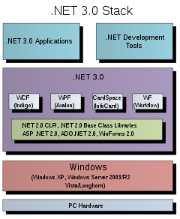](https://en.wikipedia.org/wiki/File:DotNet3.0.svg)

Figure 5.2 A part of .NET Framework 3.0

ADO.NET is conceptually divided into [*consumers*](https://en.wikipedia.org/w/index.php?title=ADO.NET_consumer&action=edit&redlink=1) and [*data providers*](https://en.wikipedia.org/wiki/ADO.NET_provider). The consumers are the applications that need access to the data, and the providers are the software components that implement the interface and thereby provide the data to the consumer.

Functionality exists in [Visual Studio](https://en.wikipedia.org/wiki/Microsoft_Visual_Studio) IDE to create specialized subclasses of the Dataset classes for a particular [database schema](https://en.wikipedia.org/wiki/Database_schema), allowing convenient access to each field in the schema through strongly typed [properties](https://en.wikipedia.org/wiki/Property_(programming)). This helps catch more programming errors at compile-time and enhances the IDE's [Intellisense](https://en.wikipedia.org/wiki/Intellisense) feature.

* + 1. JavaScript

JavaScript  often abbreviated as JS, is a [high-level](https://en.wikipedia.org/wiki/High-level_programming_language), [interpreted](https://en.wikipedia.org/wiki/Interpreted_language) [programming language](https://en.wikipedia.org/wiki/Programming_language). It is a language which is also characterized as [dynamic](https://en.wikipedia.org/wiki/Dynamic_programming_language), [weakly typed](https://en.wikipedia.org/wiki/Weak_typing), [prototype-based](https://en.wikipedia.org/wiki/Prototype-based_programming) and [multi-paradigm](https://en.wikipedia.org/wiki/Multi-paradigm_programming_language).

Alongside [HTML](https://en.wikipedia.org/wiki/HTML) and [CSS](https://en.wikipedia.org/wiki/CSS), JavaScript is one of the three core technologies of the [World Wide Web](https://en.wikipedia.org/wiki/World_Wide_Web). JavaScript enables interactive [web pages](https://en.wikipedia.org/wiki/Web_page) and thus is an essential part of [web applications](https://en.wikipedia.org/wiki/Web_application). The vast majority of [websites](https://en.wikipedia.org/wiki/Website) use it, and all major [web browsers](https://en.wikipedia.org/wiki/Web_browser) have a dedicated [JavaScript engine](https://en.wikipedia.org/wiki/JavaScript_engine) to execute it.

As a multi-paradigm language, JavaScript supports [event-driven](https://en.wikipedia.org/wiki/Event-driven_programming), [functional](https://en.wikipedia.org/wiki/Functional_programming), and [imperative](https://en.wikipedia.org/wiki/Imperative_programming) (including [object-oriented](https://en.wikipedia.org/wiki/Object-oriented_programming) and [prototype-based](https://en.wikipedia.org/wiki/Prototype-based_programming)) [programming styles](https://en.wikipedia.org/wiki/Programming_paradigm). It has an [API](https://en.wikipedia.org/wiki/Application_programming_interface) for working with text, [arrays](https://en.wikipedia.org/wiki/Array_data_type), dates, [regular expressions](https://en.wikipedia.org/wiki/Regular_expression), and basic manipulation of the [DOM](https://en.wikipedia.org/wiki/Document_Object_Model), but the language itself does not include any [I/O](https://en.wikipedia.org/wiki/Input/output), such as networking, storage, or graphics facilities, relying for these upon the host environment in which it is embedded.

Initially only implemented [client-side](https://en.wikipedia.org/wiki/Client-side) in web browsers, JavaScript engines are now embedded in many other types of host software, including [server-side](https://en.wikipedia.org/wiki/Server-side) in web servers and databases, and in non-web programs such as word processors and [PDF](https://en.wikipedia.org/wiki/Portable_Document_Format) software, and in runtime environments that make JavaScript available for writing mobile and desktop applications, including desktop widgets.

Although there are strong outward similarities between JavaScript and [Java](https://en.wikipedia.org/wiki/Java_(programming_language)), including language name, [syntax](https://en.wikipedia.org/wiki/Syntax_(programming_languages)), and respective [standard libraries](https://en.wikipedia.org/wiki/Standard_library), the two languages are distinct and differ greatly in design; JavaScript was influenced by programming languages such as [Self](https://en.wikipedia.org/wiki/Self_(programming_language)" \o "Self (programming language))and [Scheme](https://en.wikipedia.org/wiki/Scheme_(programming_language)).

* + 1. Cascading Style Sheets

Cascading Style Sheets (CSS) is a [style sheet language](https://en.wikipedia.org/wiki/Style_sheet_language) used for describing the [presentation](https://en.wikipedia.org/wiki/Presentation_semantics) of a document written in a [markup language](https://en.wikipedia.org/wiki/Markup_language) like [HTML](https://en.wikipedia.org/wiki/HTML). CSS is a cornerstone technology of the [World Wide Web](https://en.wikipedia.org/wiki/World_Wide_Web), alongside HTML and [JavaScript](https://en.wikipedia.org/wiki/JavaScript).

CSS is designed to enable the separation of presentation and content, including [layout](https://en.wikipedia.org/wiki/Page_layout), [colors](https://en.wikipedia.org/wiki/Color" \o "Color), and [fonts](https://en.wikipedia.org/wiki/Typeface). This separation can improve content [accessibility](https://en.wikipedia.org/wiki/Accessibility), provide more flexibility and control in the specification of presentation characteristics, enable multiple [web pages](https://en.wikipedia.org/wiki/Web_page) to share formatting by specifying the relevant CSS in a separate .css file, and reduce complexity and repetition in the structural content.

Separation of formatting and content also makes it feasible to present the same markup page in different styles for different rendering methods, such as on-screen, in print, by voice (via speech-based browser or [screen reader](https://en.wikipedia.org/wiki/Screen_reader)), and on [Braille-based](https://en.wikipedia.org/wiki/Braille_display) tactile devices. CSS also has rules for alternate formatting if the content is accessed on a [mobile device](https://en.wikipedia.org/wiki/Mobile_device).

The name *cascading* comes from the specified priority scheme to determine which style rule applies if more than one rule matches a particular element. This cascading priority scheme is predictable.

The CSS specifications are maintained by the [World Wide Web Consortium](https://en.wikipedia.org/wiki/World_Wide_Web_Consortium) (W3C). Internet media type ([MIME type](https://en.wikipedia.org/wiki/MIME_media_type)) text/css is registered for use with CSS by [RFC 2318](https://tools.ietf.org/html/rfc2318) (March 1998). The W3C operates a free [CSS validation service](https://en.wikipedia.org/wiki/W3C_Markup_Validation_Service#CSS_validation) for CSS documents.

In addition to HTML, other markup languages support the use of CSS, including [XHTML](https://en.wikipedia.org/wiki/XHTML), [plain XML](https://en.wikipedia.org/wiki/Plain_Old_XML), [SVG](https://en.wikipedia.org/wiki/Scalable_Vector_Graphics), and [XUL](https://en.wikipedia.org/wiki/XUL).

* + 1. HTML

Hypertext Markup Language (HTML) is the standard [markup language](https://en.wikipedia.org/wiki/Markup_language) for creating [web pages](https://en.wikipedia.org/wiki/Web_page) and [web applications](https://en.wikipedia.org/wiki/Web_application). With [Cascading Style Sheets](https://en.wikipedia.org/wiki/Cascading_Style_Sheets) (CSS) and [JavaScript](https://en.wikipedia.org/wiki/JavaScript), it forms a triad of cornerstone technologies for the [World Wide Web](https://en.wikipedia.org/wiki/World_Wide_Web).

[Web browsers](https://en.wikipedia.org/wiki/Web_browser) receive HTML documents from a [web server](https://en.wikipedia.org/wiki/Web_server) or from local storage and [render](https://en.wikipedia.org/wiki/Browser_engine) the documents into multimedia web pages. HTML describes the structure of a web page [semantically](https://en.wikipedia.org/wiki/Semantic_Web) and originally included cues for the appearance of the document.

HTML constructs, [images](https://en.wikipedia.org/wiki/HTML_element#Images_and_objects) and other objects such as [interactive forms](https://en.wikipedia.org/wiki/Fieldset) may be embedded into the rendered page. HTML provides a means to create [structured documents](https://en.wikipedia.org/wiki/Structured_document) by denoting structural [semantics](https://en.wikipedia.org/wiki/Semantics) for text such as headings, paragraphs, lists, [links](https://en.wikipedia.org/wiki/Hyperlink), quotes and other items. HTML elements are delineated by *tags*, written using [angle brackets](https://en.wikipedia.org/wiki/Bracket#Angle_brackets). Tags such as <**img** /> and <**input** /> directly introduce content into the page. Other tags such as <**p**> surround and provide information about document text and may include other tags as sub-elements. Browsers do not display the HTML tags, but use them to interpret the content of the page.

HTML can embed programs written in a [scripting language](https://en.wikipedia.org/wiki/Scripting_language) such as [JavaScript](https://en.wikipedia.org/wiki/JavaScript), which affects the behaviour and content of web pages. Inclusion of CSS defines the look and layout of content

The text between <**html**> and </**html**> describes the web page, and the text between <**body**> and </**body**> is the visible page content. The markup text <**title**>This is a title</**title**> defines the browser page title.

The Document Type Declaration <!DOCTYPE html> is for HTML5. If a declaration is not included, various browsers will revert to "[quirks mode](https://en.wikipedia.org/wiki/Quirks_mode)" for rendering.

End Result

6

1. End Result
   1. Tables

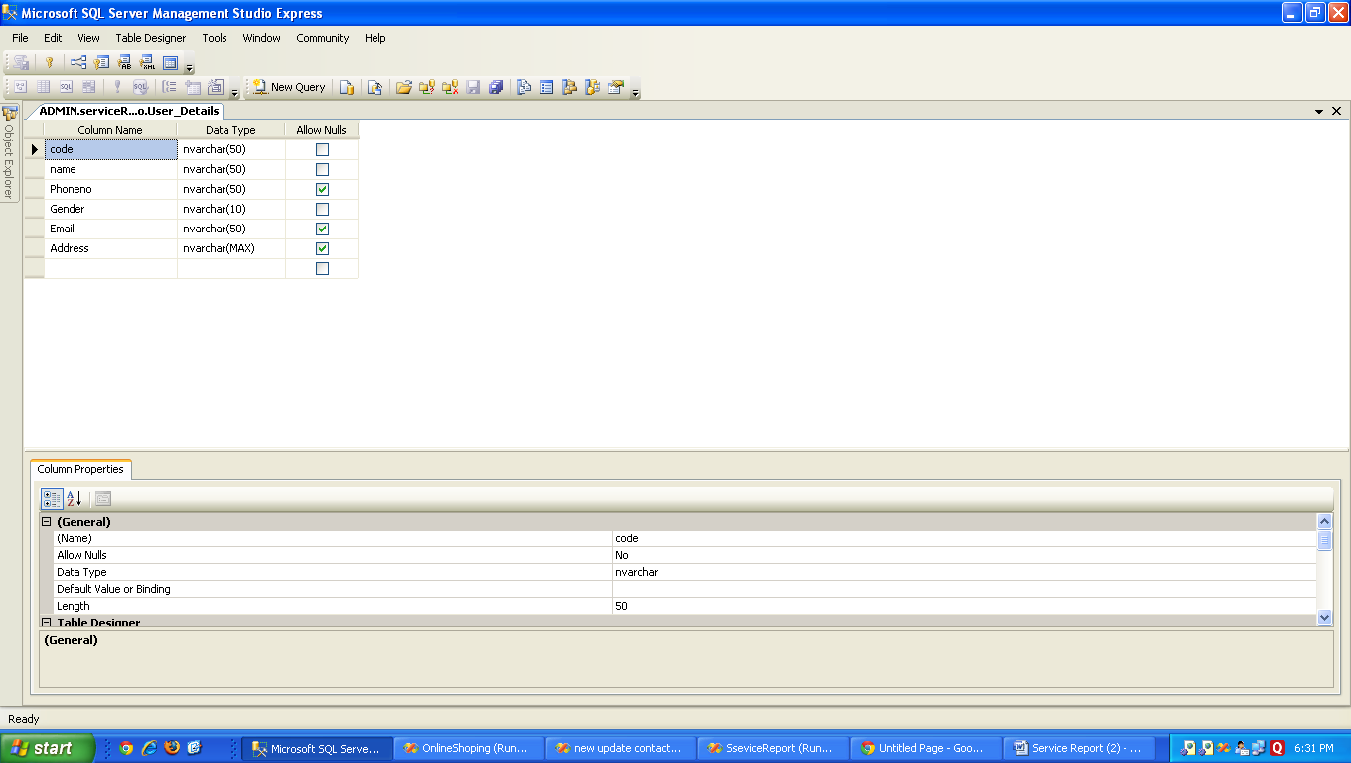

Figure 6.1 User Details

All user Details like name, phone no, Gender, Email, Address

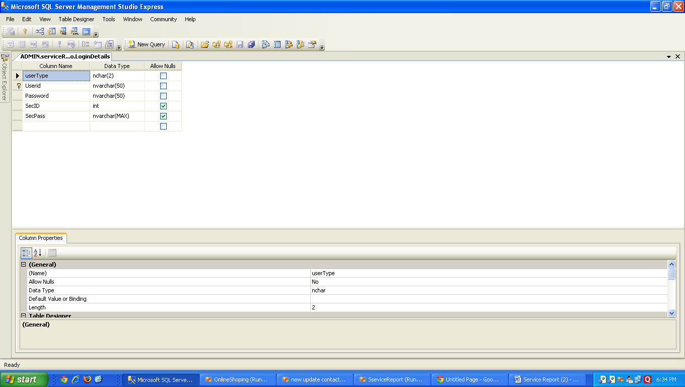

Figure 6.2 Login Details

Stores login details of users

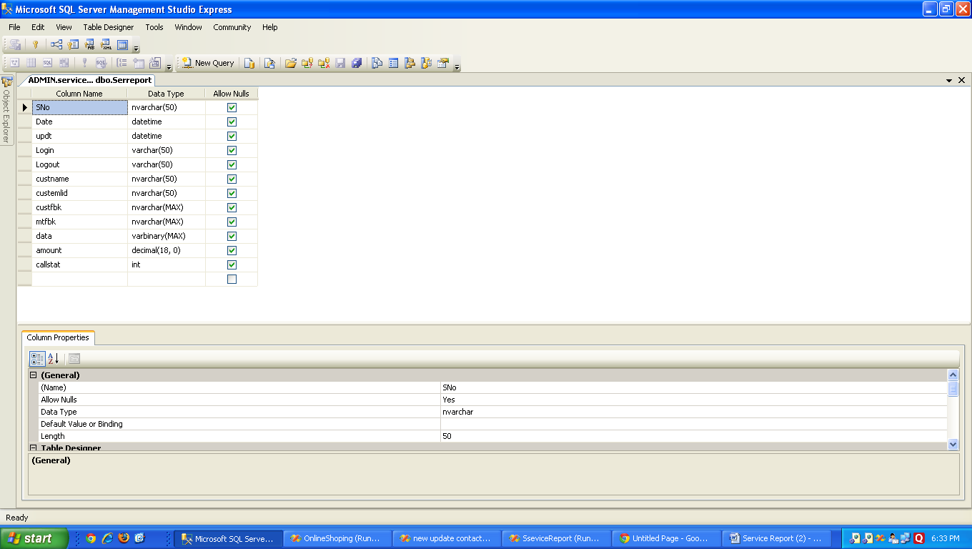

Figure 6.3 Service Report  
 Stores the report in the database.  
 The date, login, logout times, feedbacks, image data, amount, call status.

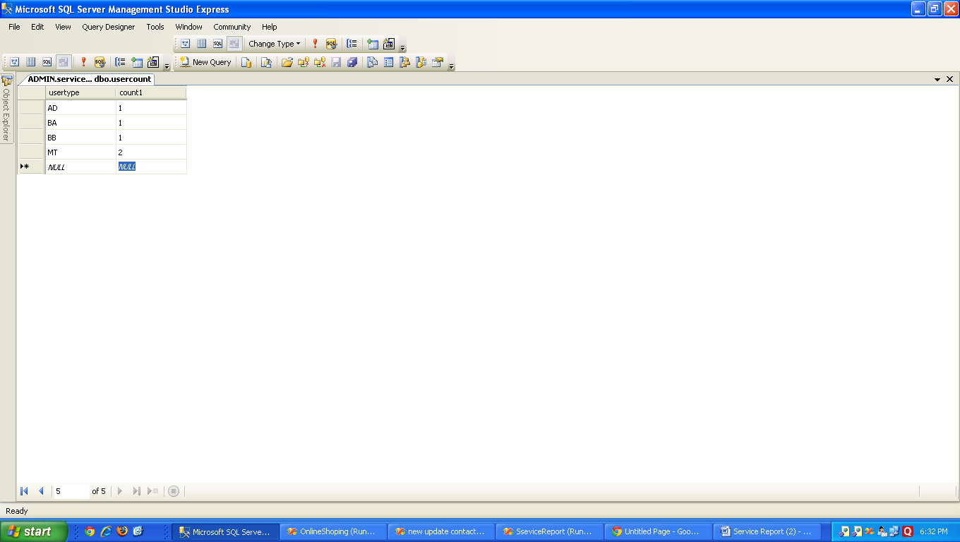

Figure 6.4 User Count  
 The count of all individual usertypes, AD, BA, BB, MT

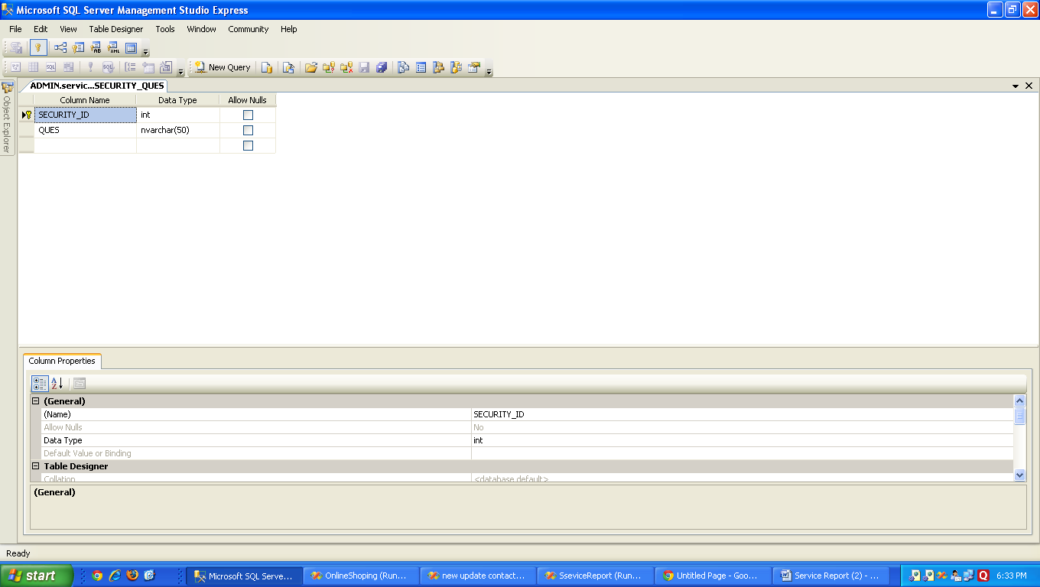

Figure 6.5 Security Ques  
 Security Questions with their unique IDs.

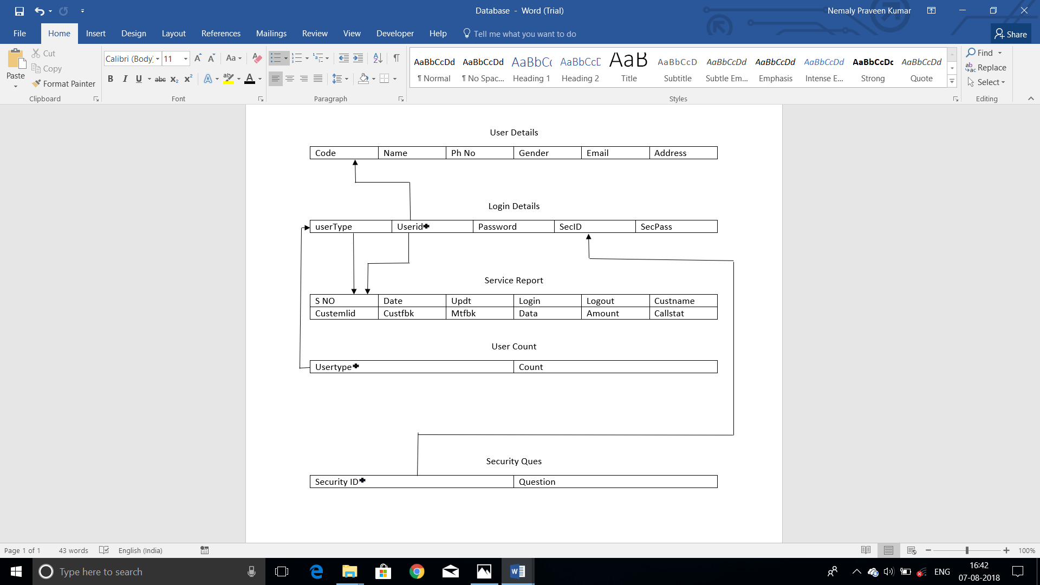

* Primary Key

Figure 6.6 SCHEMA

* 1. Web Pages

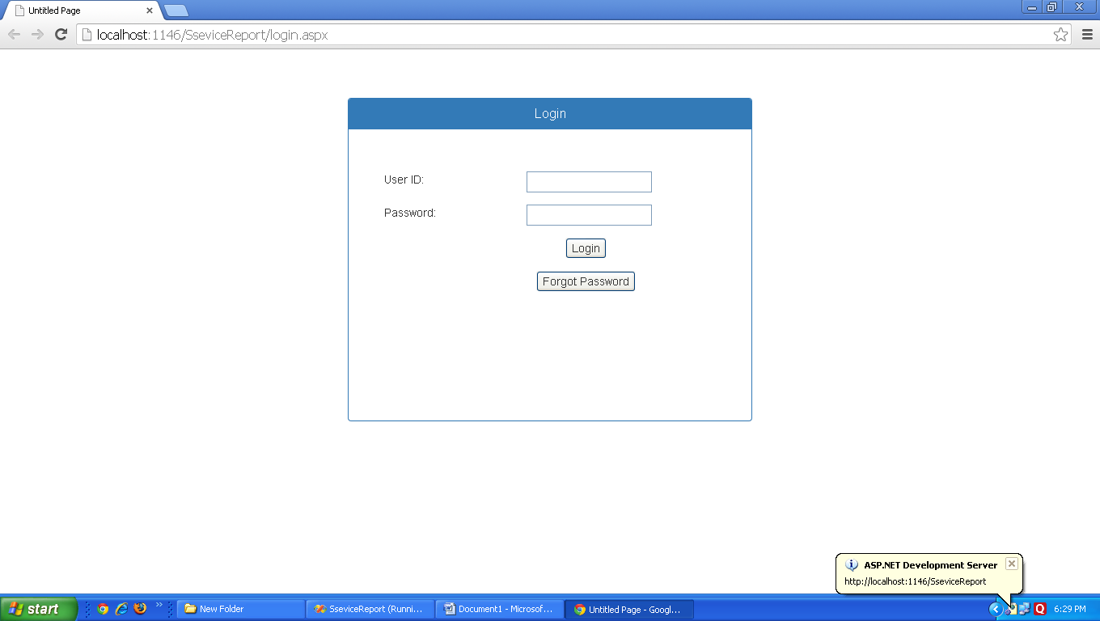

Figure 6.7 Login Page  
The web page when a user tries to log into the system. On valid credentials, the user is given access into the system. Invalid credentials do not grant permission.

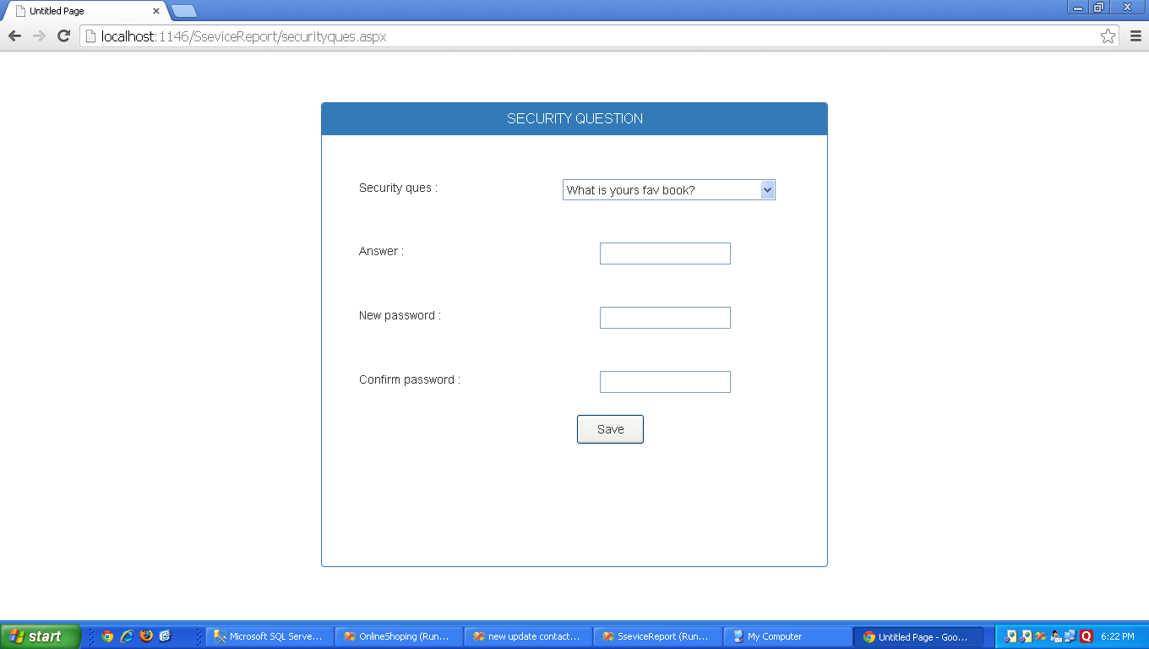

Figure 6.8 Security Question  
This page is accessible only on the 1st login. The user can answer a security question that will help him to access his account in case he forgets the password, And to change the default password.

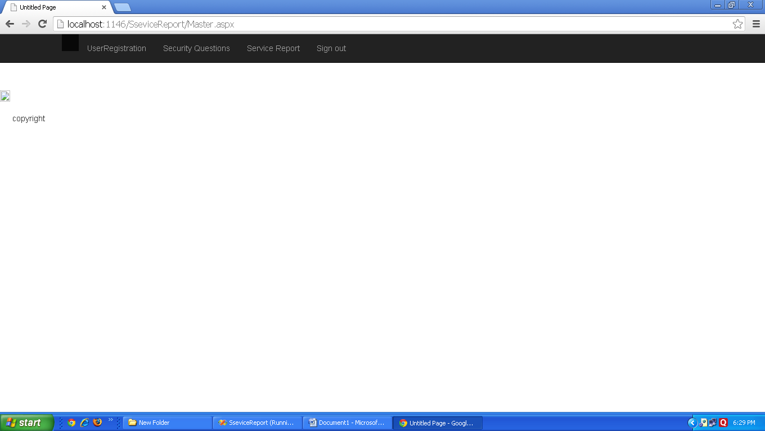

Figure 6.9 Home Page  
The page that is first shown to the user. From here the user can navigate to any other page that he wants to. It consists of menu buttons containing links to other pages.

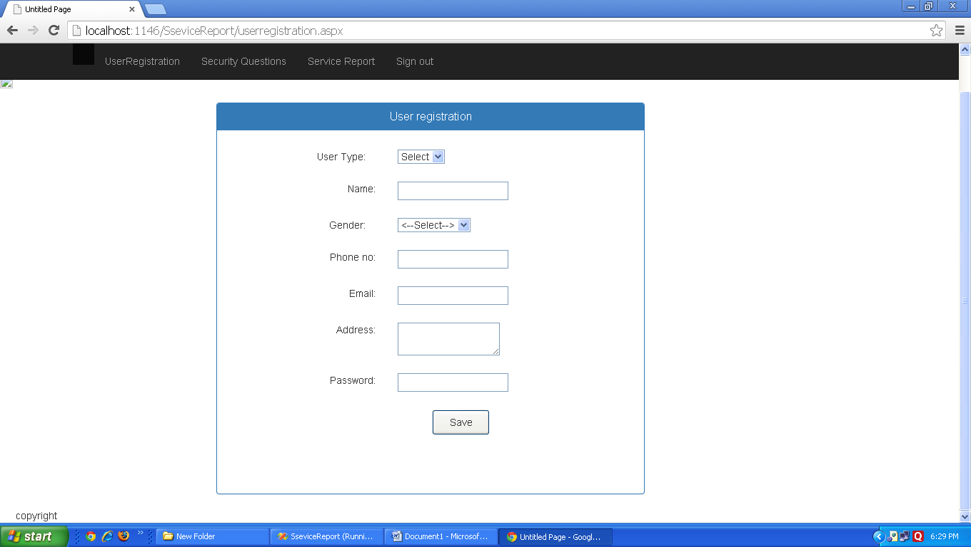

Figure 6.10 User Registration  
A form to register new users. By filling in their details

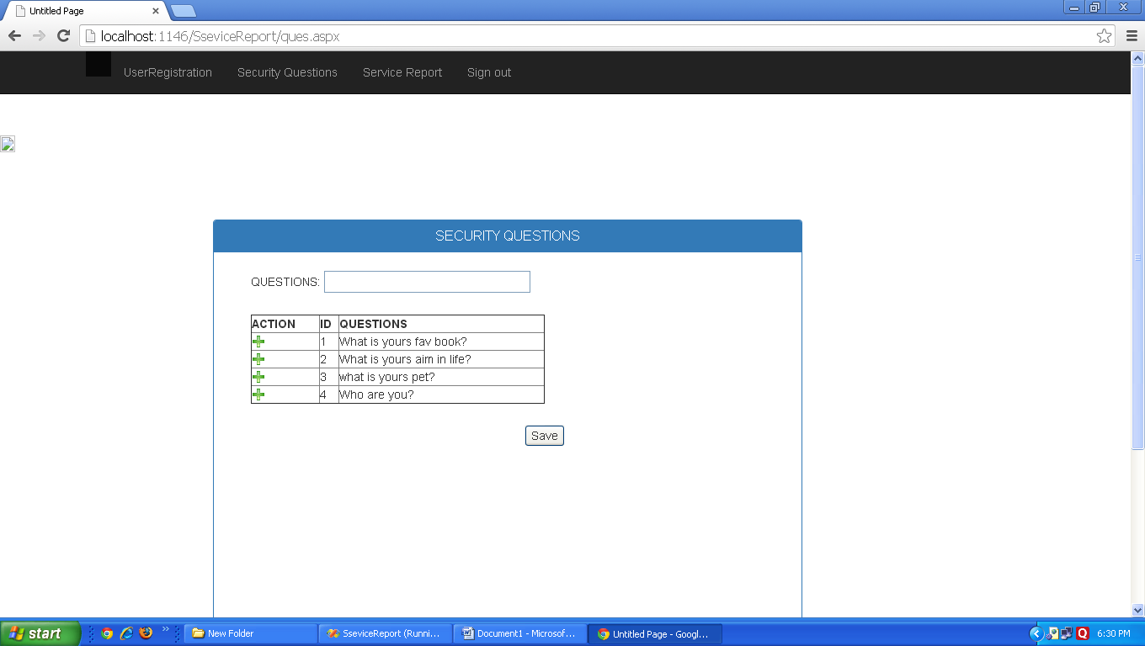

Figure 6.11 Security Questions

Page to update the Security Questions. This page can be accessed only by an Admin.

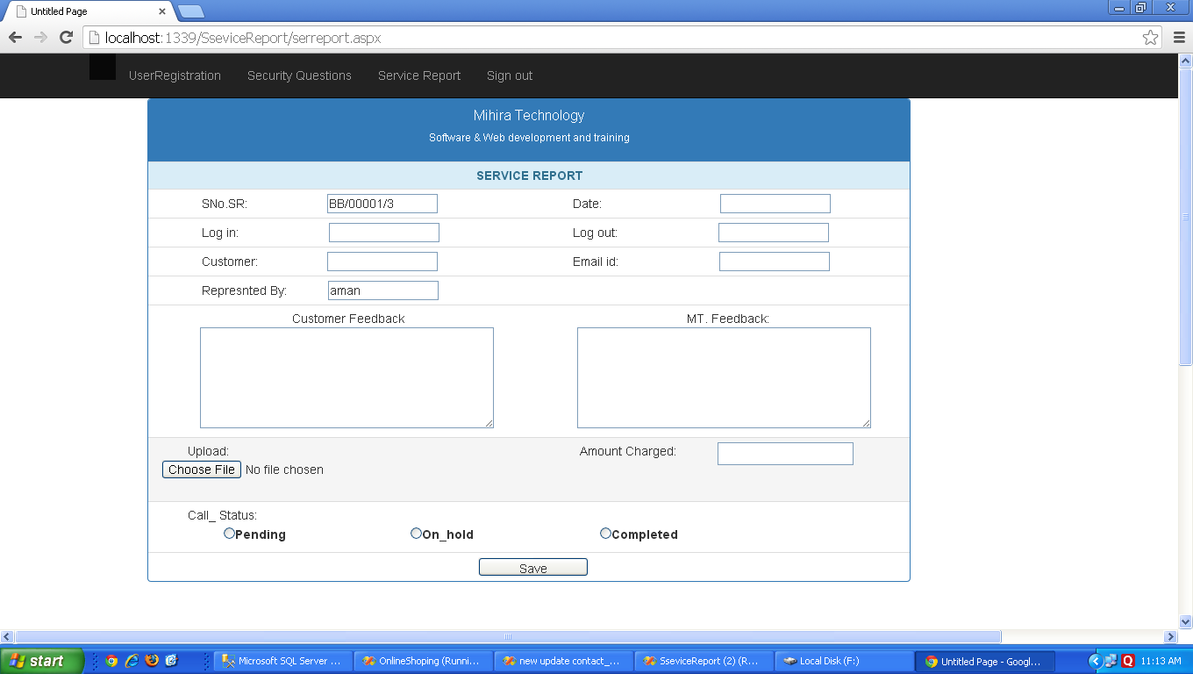

Figure 6.12 Service Report  
A page which accepts the details of the customer`s service status report, with some being auto generated and then stores the data in a database.

1. **CONCLUSION and future enhancements**

* **CONCLUSION**

After completing this project I came to the conclusion that maintaining database is a little tricky thing if we do it on paper. But implementing database management on SQL plus using C# as front end makes the task simpler. Handling data by our database application is very easier as we can retrieve any data by a single click of a button. Further I came to know that we can use stored procedures at back end in order to update data of any table by using front end.

So, all these features of DBMS and ASP.NET are very useful as it helps us to understand all the aspect of database and helps to retrieve any data or update the data. Further its make the job easier for the people who use this application as it helps them a lot and it can be used in a care free manner. So at last coming to the end of the project it was a good experience while learning the various concepts of database and applying them practically.

* **Future enhancements**

Future enhancements which can be included in this project are like a proper data entry system can be formed for every table. And adding the search query to retrieve important data that is needed. Moreover the application can be made more User friendly so that it’s easier for the user to understand how to use the application and deal with all the data they have.